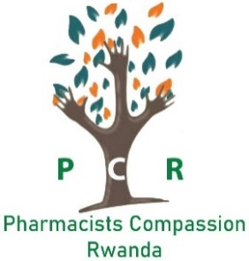

**NARRATIVE REPORT OF THE PHARMACISTS COMPASSION RWANDA ACTIVITIES OF YEAR 2022-2023**

**ACTIVITY 1: Fighting against addictions (drugs, alcohol, prostitution etc.), and ensuring effective rehabilitation of the addicts**

**Type of Activity:** counselling and Psychoeducation

**Venue:** Purpose Rwanda Head Office, Kigali

**Number of beneficiaries:** 500 people

**OBJECTIVES**

1. Active listening to the stories of our beneficiaries to explore their feelings    and perceptions about what they are going through.
2. Accompany them through the journey of Healing and total restoration.
3. Help our Beneficiaries to redeem Hope for life and confidence in themselves.
4. Unlock the potential of our beneficiaries and shed light on the possibilities to achieve their dreams.

**TARGET GROUP**

With approximately 78% of the Rwandan population under the age of 35, the youth undoubtedly play a critical role in shaping the country's future. However, it is disconcerting to note that a significant proportion of drug abusers fall within this age bracket - the very same demographic that is expected to lead and drive progress in the country. Without decisive action to curb this problem of drug abuse and its associated delinquent behaviors among the youth, the future of our nation looks bleak. As such, our project places a strong emphasis on prioritizing youth over other demographics.

**Description of methodology**

As PCR, we have adopted a comprehensive approach by providing a safe space where our beneficiaries feel welcomed, and our teaching model focuses on the underlying causes of addiction and provides ongoing support for individuals toward complete recovery.

**Description of activity**

Our project was born out of the need for a long-lasting solution for individuals struggling with addiction. Our approach involves walking alongside them throughout their transformation and healing journey for a period of 13 weeks. To achieve this, we have designed a program that offers specific lessons each week that are aimed at identifying and addressing the root causes of addiction.

Our approach is unique as we use an occupational and goal-setting approach to help our beneficiaries change their habits and attitudes, improve their daily lives, and regain hope for a better future. Our program is designed to redeem the dreams of our beneficiaries, regardless of their past struggles with addiction. With our approach, we are confident that we can help individuals overcome addiction and build a brighter future for themselves.

Photos

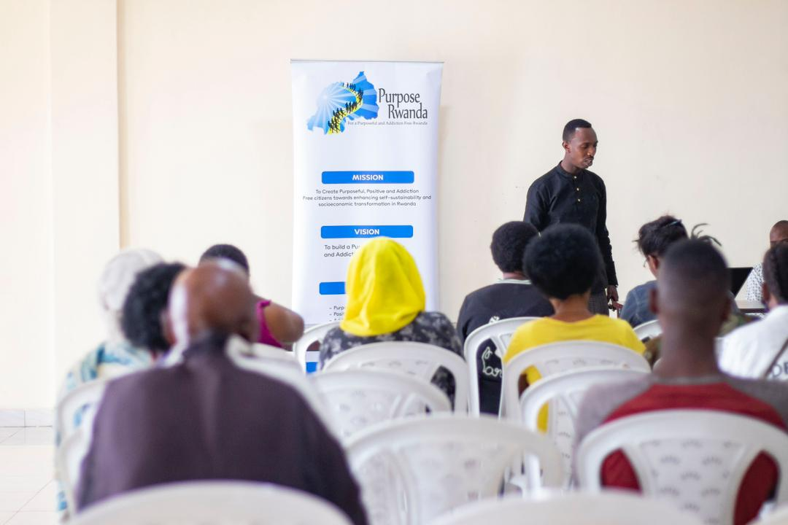

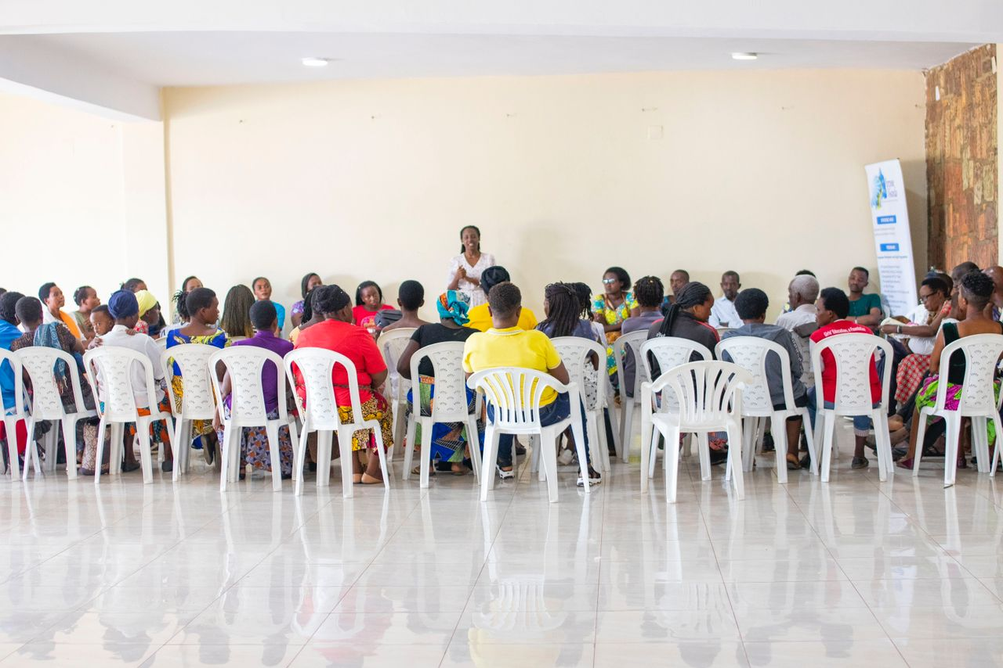

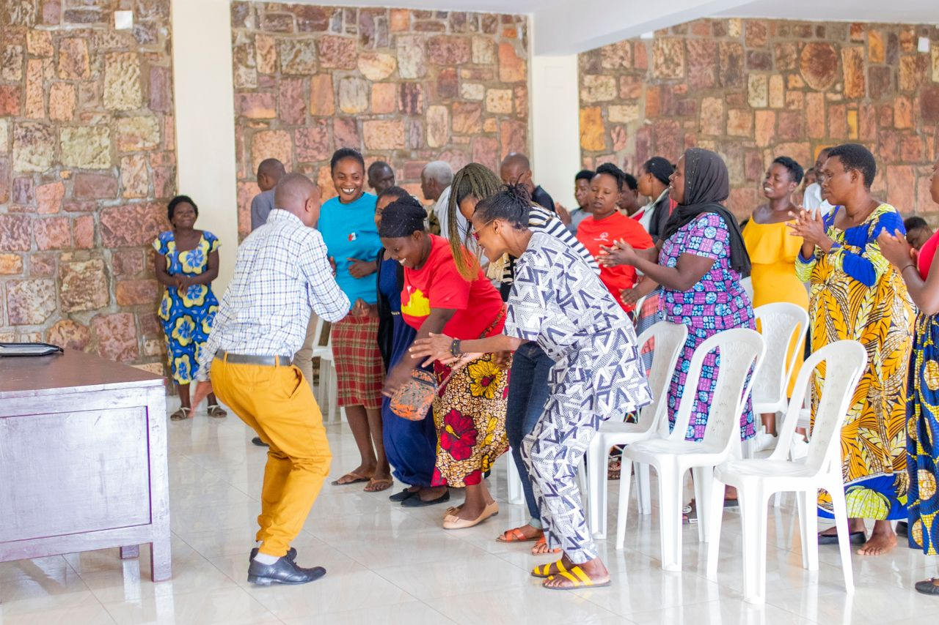

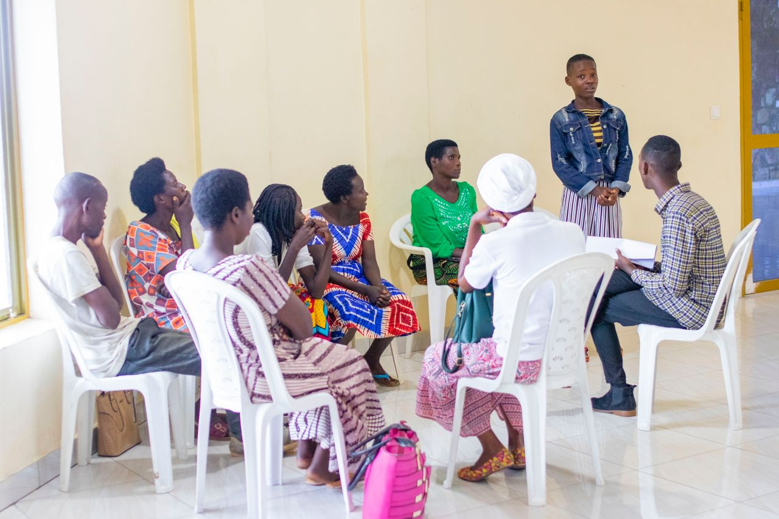

**ACTIVITY 2:**

We have successfully conducted mental health training sessions for the children benefiting from the "Child's Journey" program, an empathetic initiative by Prison Fellowship aimed at supporting children with confined parents.

**Objective of the activity.**

The purpose of the program is to accompanying the beneficiaries through different challenges they face and sustaining their mental well-being.

**Venue:** Children’s Journey Program office, Kigali

**Number of beneficiaries:** 30 children

**Description of the activity**

The child’s Journey restores the lives of children through practical care, spiritual and emotional support, and opportunities to flourish. Breaking the cycle of crime for one of the most vulnerable populations-children of prisoners.

Our session focused on sharing life challenges and testimonies to inspire children to persevere through difficulties, many of which arise from living without parents who are in prison. Our approach aims to provide a nurturing environment where these children feel loved and accepted, helping to mend the emotional void caused by parental absence

**Photos**

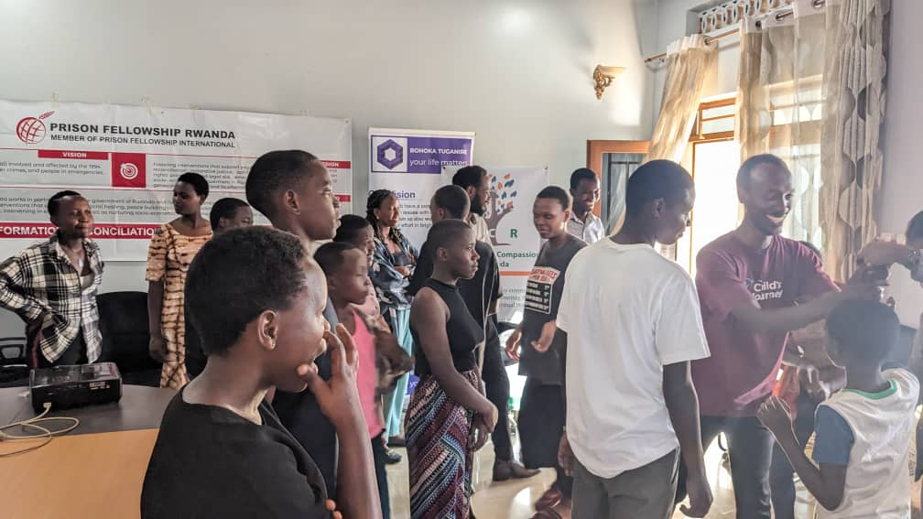

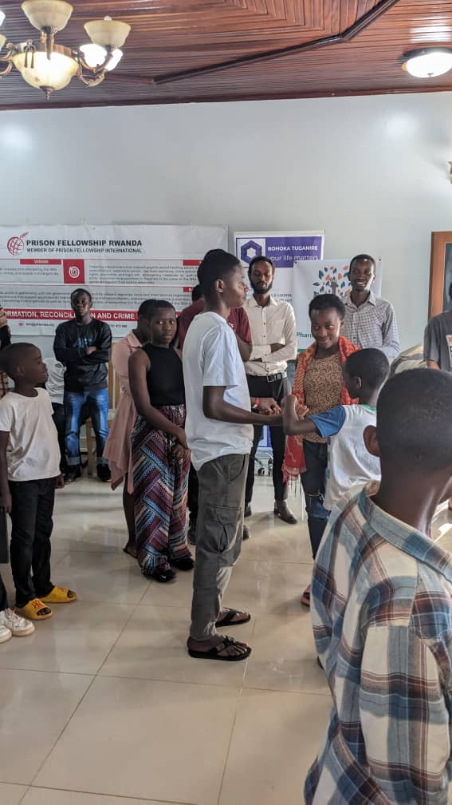

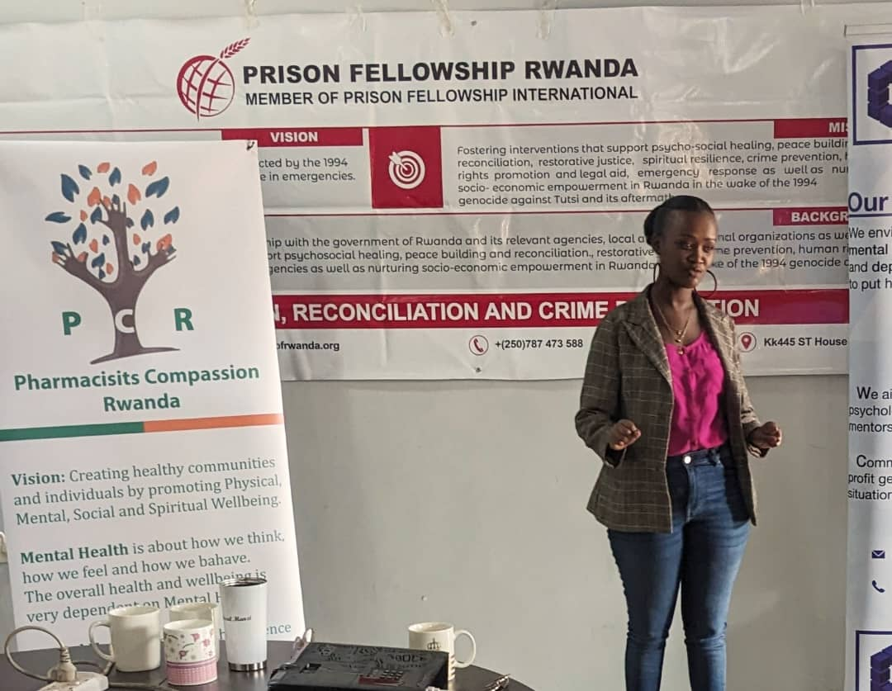

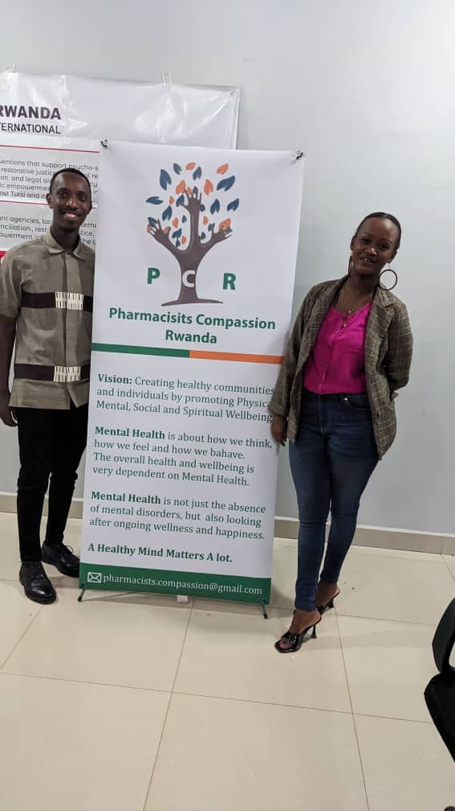

**ACTIVITY 3:**

Mental health awareness talk shows on Radio Rwanda.

**Type of Activity:** Mental health Awareness

**Venue:** RBA, Studios

**Beneficiaries:** over 50 000 people listened the program

**Objective of the program**

In partnership with Purpose Rwanda, our goal was to educate and raise awareness about mental health within the community. We aimed to inform the community about the detrimental effects of drug abuse and other unhealthy behaviors that can impact mental wellbeing. Additionally, we provided education on various types of addiction, urging individuals to break free from harmful habits. We actively encourage those struggling with addiction to seek assistance, by attending counseling or other psychotherapeutic services available at our institutions.



<https://youtu.be/4lu6lPPXDEc>

Prepared By:

DUSENGIMANA Pacifique

Executive Director

Pharmacists Compassion Rwanda